ISSACK WAITHAKA
cs-sa07-24085

Passive Versus Active Recon
- Reconnaissance is gathering information about a target.
- Passive reconnaissance rely on information that is publicly available
- Active reconnaissance requires direct engagement with the target

Questions

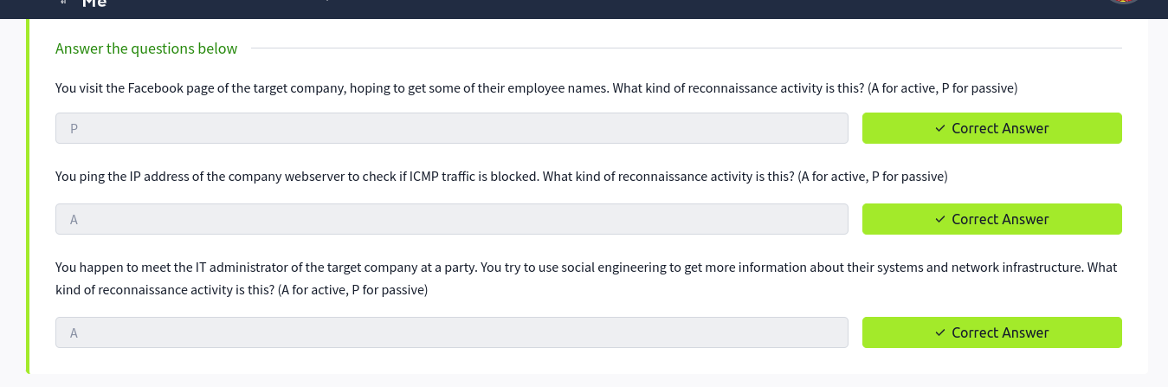

Whois
- Listens on port 43 for incoming requests
- Replies with various information related to the domain requested

Questions
1.

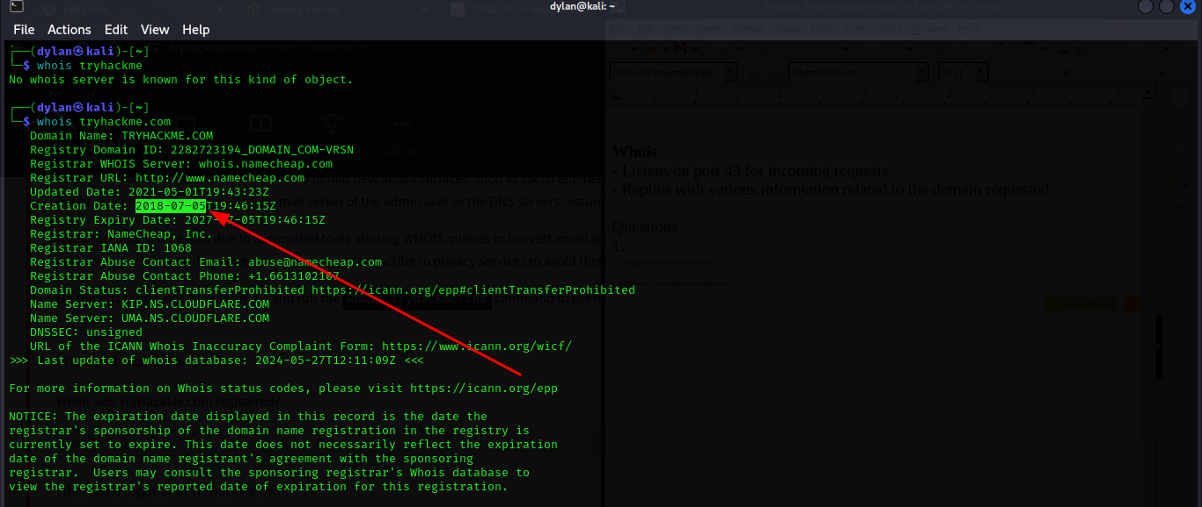

2.

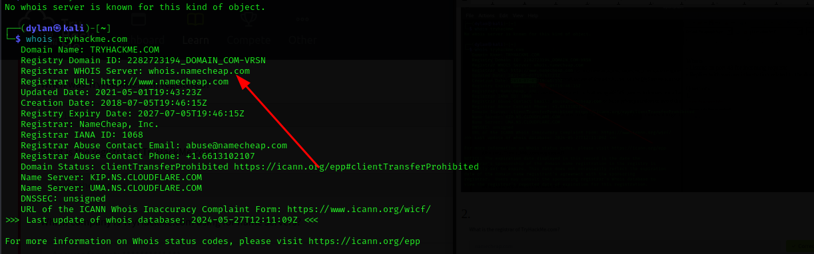
3.

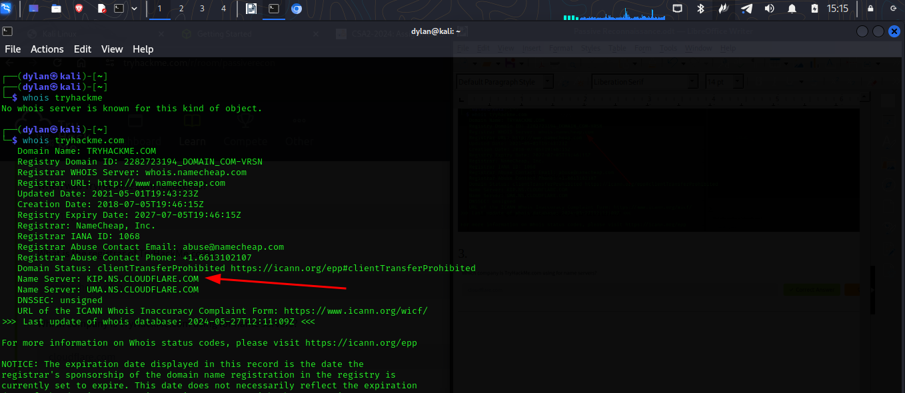

nslookup and dig
- nslookup(name server lookup) is used to find the IP address of a domain name

Questions
1.



DNSDumpster
- It is a search engine mainly used to compile a list of publicly know subdomains
- It will also represent collected information graphically
Questions
1.

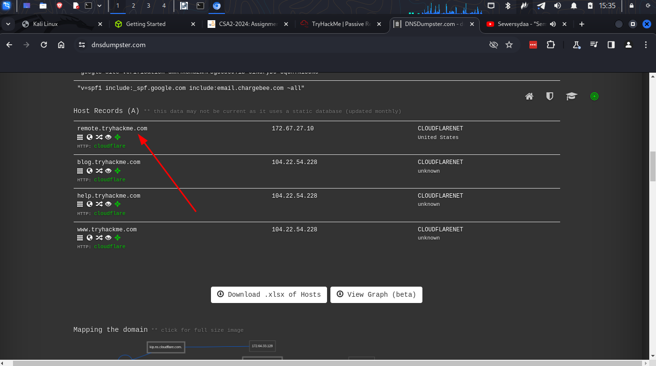

Shodan.io
- Helps to learn information about a target network without actively connecting to it
- Can also learn about connected and exposed devices belonging to an organization
- It tries to connect to every device online to build a search engine of connected things.

Questions
1.

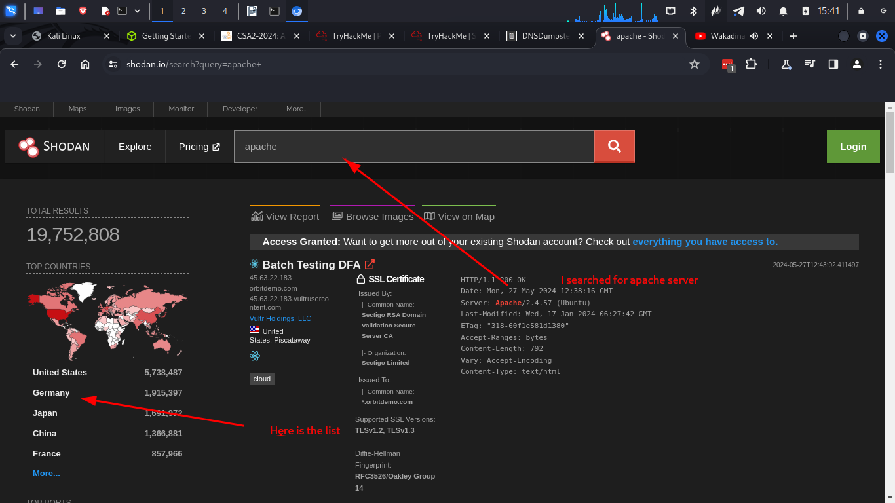
2.

3.



Conclusion
- In this room I was able to through some of the tools that make it possible to access information that is publicly available(passive reconnaissance). The tools include whois, nslookup and dig. I also learnt about shodan.io and DNSDumpster which helps in collection of information.

